**Smart Water Management**

**Smart water management using IoT:**

In this technological world, IoT has created a huge impact on everyone’s life. Our cities are occupied with smart homes, smart traffic management systems, etc. As of now, the [water management](https://www.teamtweaks.com/smart-water-management) techniques are highly triggered by [IoT](https://www.teamtweaks.com/internet-of-things).

It ensures a well-defined utilization of water preserving our valuable resources and making 100% life convenient. In most countries, there is no proper management of the resource. It automatically leads to water scarcity.

A recent report exclaims that about fifty percent of the world population globally faces water scarcity in another four years. These points clearly point that water will be a precious resource in the upcoming days.

**An exclusive insight:**

In this era, the IoT integrated [smart water management system](https://www.teamtweaks.com/smart-water-management) is the best technique to save water in an efficient manner. The water supply in both the industrial and commercial areas has occupied the smart IoT water measuring units.

Series of sensors like pressure sensor, volume sensor, pH sensor, turbidity is fixed along the pipelines which will occupy the data and send it to the cloud storage.

The above-mentioned sensors are mainly used to test the quality of the water in a well-defined manner.

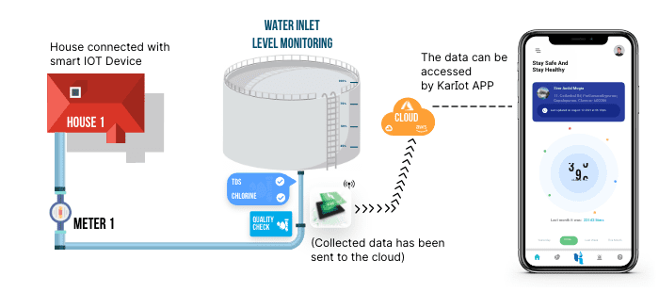

Finally, water is moved towards the overhead tanks. Here, measuring the quality and quantity of water is also feasible. It can be precisely seen through smart [mobile apps](https://www.teamtweaks.com/).

The government must take instant actions and provide intelligent protocols to save water and use it wisely. If consuming water is assigned to procure credit, then it automatically encourages saving water. At the same time, it is possible to detect the leakage in the overall pipe system by triggering a supply of water.

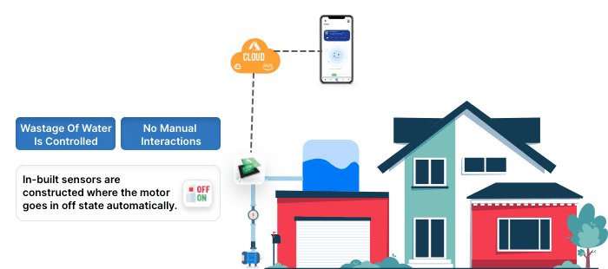

The outlet is also used for other purposes like a smart drainage system. Impurities & suspended particles are checked repeatedly and eradicate the wastage in the water. By a deeper analysis process like adding chemicals and agents purifies the water without any contaminants. Here, the water is used for agriculture farming, cleaning floors, washing dresses, etc.

On the other side of the flip, smart water technologies aids in the utilization of water in multiple ways. For example, the materials used for the construction of roads possess the ability to sink water to complete the roadside.

Through the point of collecting source, water is provided for the multiple needs especially in the field of agriculture, for growing plants, etc. Rainwater harvesting is used for cleaning the highway roads which are integrated with the underground tank. By using the surveillance cameras, the roads will be checked it is clean or not. In case if the roads are not neat, the sprayers are used to clean the entire city. The planting of seeds & trees enhances the systematic water storage system.

Hence, we can save more water for our upcoming generation and provide our contribution to a healthy environment. This one automatically helps in the revolution of water management too.

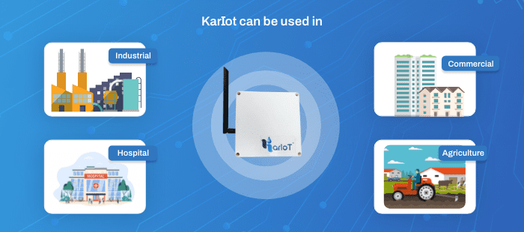

**Role of IoT in Water Industry**

**Water Preservation:**

It is essential for the reservoirs and tending to occupy the sensors and components which are typically configured to show the level of water present in it. With the aid of sensors, the concerned water level in the reservoir is sent to the server at uniform intervals to compute the level of water consumed on the regular basis. The complete process of predicting the water level which reflects in the main server aids in water conservation.

**Smart Irrigation:**

Generally, water preservation is one of the important processes, especially in urban areas. Maintaining water consumption is the most challenging one. Here, the problems can be solved by using IoT methodologies without any complications.

**Systematic Smart Water Units**

Want to acquire more information about the Smart [Water Management system](https://www.karikala.in/)? Scroll down the page.

Everyone is aware that water is the most valued & priceless resource in this gigantic world. Due to the enormous changes in the ozone layer, we are experiencing unexpected changes, especially in climatic conditions. Due to poor management of water resources and inefficient rainwater harvesting, we are suffering from extreme drought conditions, especially in the summer seasons. The robust IoT technology helps in efficient and effective smart water management.

While discussing in detail, most of the houses in our country especially in the southern part, the people have constructed large wells where the water is pumped easily to fulfill our daily needs. In the tank, if there is no water, the manual process takes. In case if the water is filled, the water falls to the ground then one should go and switch off. As of now, due to technological advancement, every process is being automated. To avoid the wastage of water in the manual process, in-built sensors are constructed where the motor goes in off state automatically. Here, the commercial automatic controllers & ultrasonic sensor plays a vital role too.

Benefits of smart water:

1.Water Conservation: Smart water systems can monitor and optimize water usage, helping to reduce water waste and conserve this valuable resource.

2.Leak Detection: These systems can quickly identify leaks and notify homeowners or businesses, preventing water damage and saving money on water bills.

3.Improved Water Quality: Smart water filters and sensors can enhance water quality by removing impurities and contaminants, ensuring safe and clean drinking water.

4.Energy Efficiency: By optimizing water heating and distribution, smart water heaters and pumps can reduce energy consumption and lower utility costs.

5.Convenience: Smart water meters and apps allow users to track their water usage in real-time, helping them make informed decisions about water consumption.

6.Remote Monitoring: Users can remotely monitor their water systems, making it easier to detect and address issues even when away from home.

7.Environmental Impact: Smart water technology can contribute to environmental sustainability by reducing water waste and conserving energy.

8.Data Insights: The data collected by smart water systems can provide valuable insights for water utilities to improve infrastructure and efficiency.

9.Cost Savings: Over time, the energy and water savings from smart water systems can result in cost savings for homeowners and businesses.

10.Water Security: Smart water technology can help ensure a reliable water supply by alerting authorities to potential issues or vulnerabilities in the water distribution system.

Overall, smart water technology offers a range of benefits that contribute to water conservation, cost savings, and improved water quality and security.